Results of the GLM Procedure One Way ANOVA on time until purge of mice heads

|  |  |  |
| --- | --- | --- |
| **Class Level Information** | | |
| **Class** | **Levels** | **Values** |
| **Dummy** | 9 | 1 2 3 4 5 6 7 8 9 |

|  |  |
| --- | --- |
| **Number of Observations Read** | 270 |
| **Number of Observations Used** | 270 |

Dependent Variable: Time until purge of heads

|  |  |  |  |  |  |
| --- | --- | --- | --- | --- | --- |
| **Source** | **DF** | **Sum of Squares** | **Mean Square** | **F Value** | **p** |
| **Model** | 8 | 3235.7630 | 404.4704 | 1.02 | 0.4245 |
| **Error** | 261 | 103949.0667 | 398.2723 |  |  |
| **Corrected Total** | 269 | 107184.8296 |  |  |  |

|  |  |  |  |
| --- | --- | --- | --- |
| **R-Square** | **Coeff Var** | **Root MSE** | **Time_until_purge Mean** |
| 0.030189 | 32.06573 | 19.95676 | 62.23704 |

|  |  |  |  |  |  |
| --- | --- | --- | --- | --- | --- |
| **Source** | **DF** | **Type I SS** | **Mean Square** | **F Value** | **p** |
| **Dummy** | 8 | 3235.762963 | 404.470370 | 1.02 | 0.4245 |

|  |  |  |  |  |  |
| --- | --- | --- | --- | --- | --- |
| **Source** | **DF** | **Type III SS** | **Mean Square** | **F Value** | **p** |
| **Dummy** | 8 | 3235.762963 | 404.470370 | 1.02 | 0.4245 |

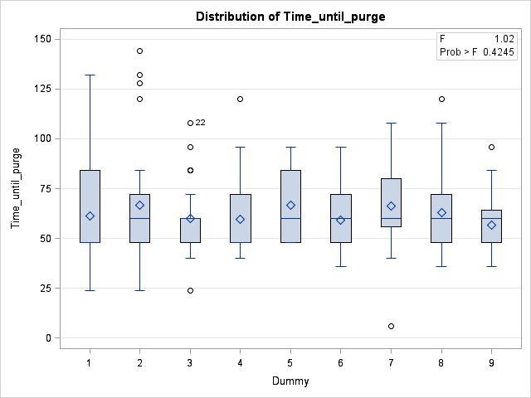

# The SAS System

The GLM Procedure

Ryan-Einot-Gabriel-Welsch Multiple Range Test for Time until purge of heads

**Note:** This test controls the Type I experimentwise error rate.

|  |  |
| --- | --- |
| **Alpha** | 0.05 |
| **Error Degrees of Freedom** | 261 |
| **Error Mean Square** | 398.2723 |

|  |  |  |  |  |  |  |  |  |
| --- | --- | --- | --- | --- | --- | --- | --- | --- |
| **Number of Means** | **2** | **3** | **4** | **5** | **6** | **7** | **8** | **9** |
| **Critical Range** | 13.141364 | 14.22366 | 14.816233 | 15.217243 | 15.517422 | 15.755568 | 15.755568 | 16.117956 |

|  |  |  |  |
| --- | --- | --- | --- |
| **Means with the same letter are not significantly different.** | | | |
| **REGWQ Grouping** | **Mean** | **N** | **Treatment** |
| A | 66.800 | 30 | *Escherichia coli &* *Ignatzschineria indica* |
| A |  |  |  |
| A | 66.667 | 30 | *Escherichia coli* |
| A |  |  |  |
| A | 66.467 | 30 | *Salmonella enterica* *&* *Ignatzschineria indica* |
| A |  |  |  |
| A | 62.933 | 30 | Negative control |
| A |  |  |  |
| A | 61.200 | 30 | *Ignatzschineria indica* |
| A |  |  |  |
| A | 60.133 | 30 | *Bacillus licheniformis* |
| A |  |  |  |
| A | 59.733 | 30 | *Salmonella enterica* |
| A |  |  |  |
| A | 59.333 | 30 | *Bacillus licheniformis* *&* *Ignatzschineria indica* |
| A |  |  |  |
| A | 56.867 | 30 | Positive control |

Tukey's Studentized Range (HSD) Test for Time until purge of heads

**Note:** This test controls the Type I experimentwise error rate, but it generally has a higher Type II error rate than REGWQ.

|  |  |
| --- | --- |
| **Alpha** | 0.05 |
| **Error Degrees of Freedom** | 261 |
| **Error Mean Square** | 398.2723 |
| **Critical Value of Studentized Range** | 4.42365 |
| **Minimum Significant Difference** | 16.118 |

|  |  |  |  |
| --- | --- | --- | --- |
| **Means with the same letter are not significantly different.** | | | |
| **Tukey Grouping** | **Mean** | **N** | **Dummy** |
| A | 66.800 | 30 | *Escherichia coli &* *Ignatzschineria indica* |
| A |  |  |  |
| A | 66.667 | 30 | *Escherichia coli* |
| A |  |  |  |
| A | 66.467 | 30 | *Salmonella enterica* *&* *Ignatzschineria indica* |
| A |  |  |  |
| A | 62.933 | 30 | Negative control |
| A |  |  |  |
| A | 61.200 | 30 | *Ignatzschineria indica* |
| A |  |  |  |
| A | 60.133 | 30 | *Bacillus licheniformis* |
| A |  |  |  |
| A | 59.733 | 30 | *Salmonella enterica* |
| A |  |  |  |
| A | 59.333 | 30 | *Bacillus licheniformis* *&* *Ignatzschineria indica* |
| A |  |  |  |
| A | 56.867 | 30 | Positive control |